List of components used

chasis

* acrylic 2mm material-2 layers
* 42mm rubber wheel-2
* Caster wheel-1
* Nuts and bolts
* N20 motor brackets-2

Power supply circuit

* Male headers
* 7805 voltage regulator
* 10uF capacitor-1
* 0.1uf capacitor-1

Main circuit included microcontroller and comparators

* Pic 16f877a microcontroller-1
* 16MHz crystal oscillator-1
* 22pF capacitors-2
* 40pin IC socket -1
* Male headers
* LM324N comparator-2
* 14 pin IC socket-2

Motor controller circuit

* 16 pin IC socket-1
* 22pF capacitors-2
* Male Headers

Sensor circuit

* TCRT 5000 sensor-8
* 4.7K variable resistor-8
* 150ohm resistor-8
* 1K resistor-8
* Male headers

Wires

* Male to male jumper wires
* Male to Female jumper wires
* Female to female jumper wires
* Wires with connectors

Other components

* Blue Led -1
* Rocker switch-1
* 7.4V 2200mAh Li-Po rechargeable battery-1
* Li-Po battery charger-1
* 200rpm DC micro gear motor-2
* Insulating Tape
* Double Tape
* Solder Iron
* Lead

Equipment used to make PCBs (Printed Circuit Boards)

* Copper board
* FECL3
* Drill machine
* Nail Polish

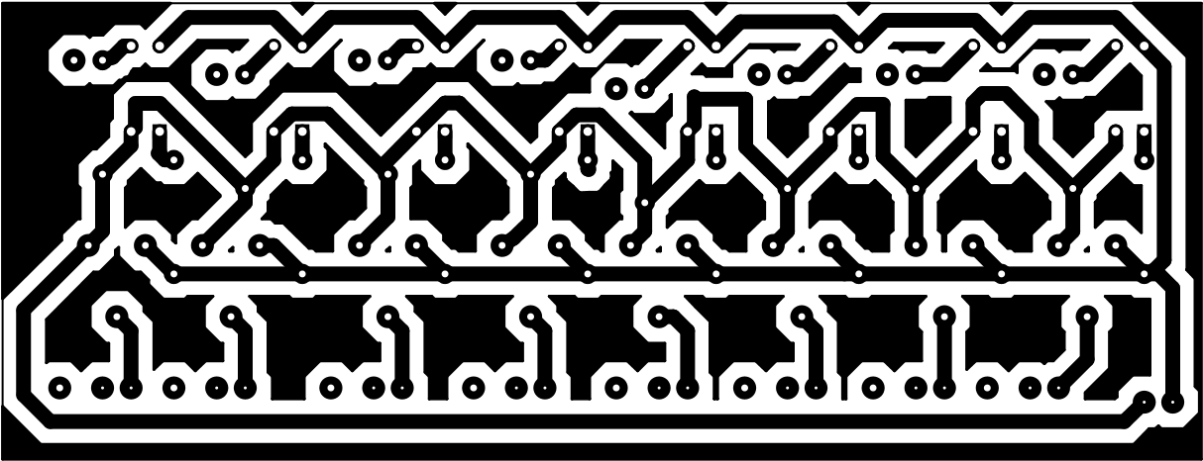**Layouts of circuits**

Sensor panel

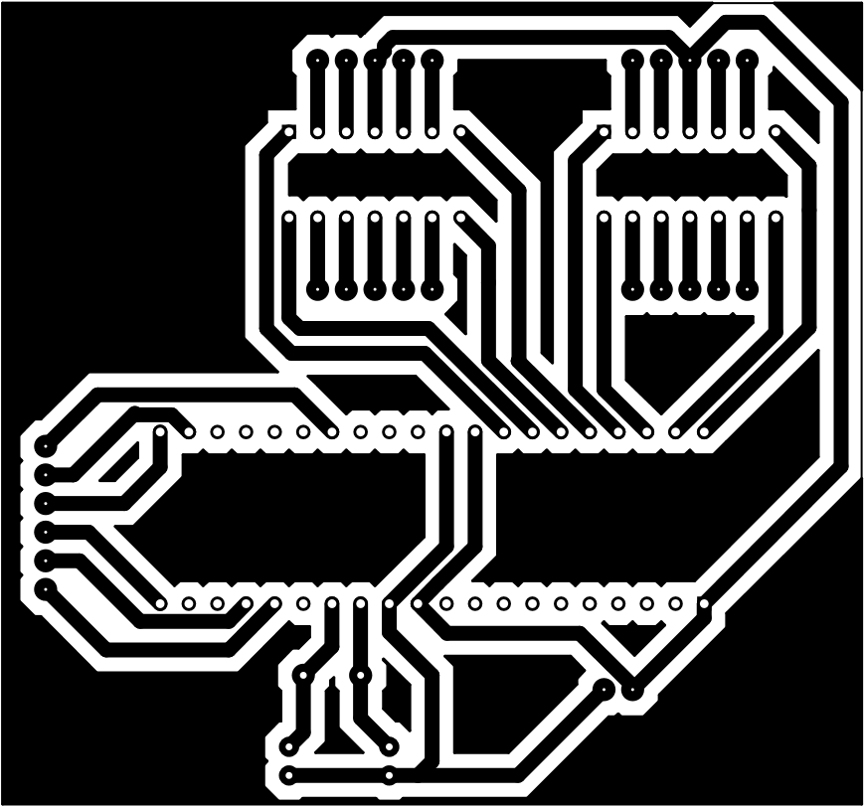Main Circuit

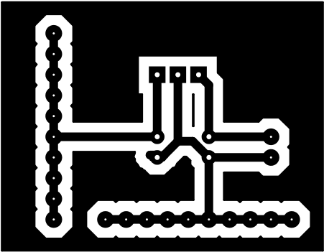Power supply

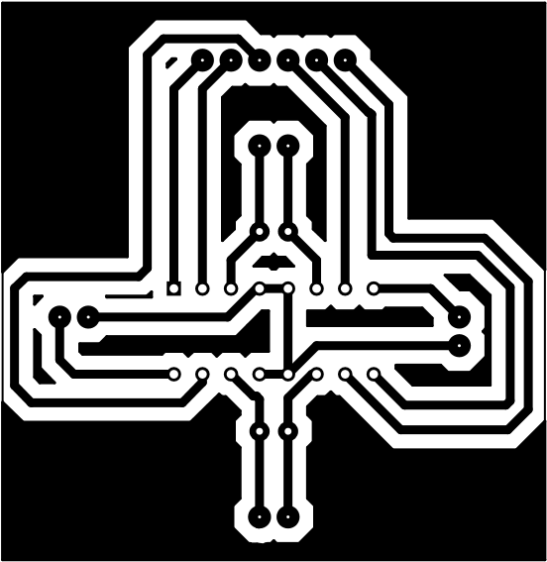Motor circuit

**Schematic Diagrams**

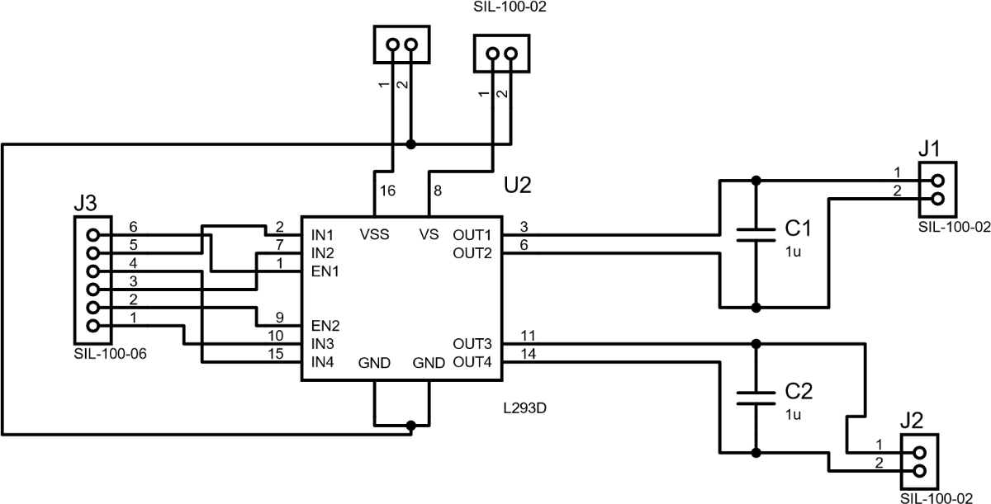Motor Circuit

Power Supply circuit

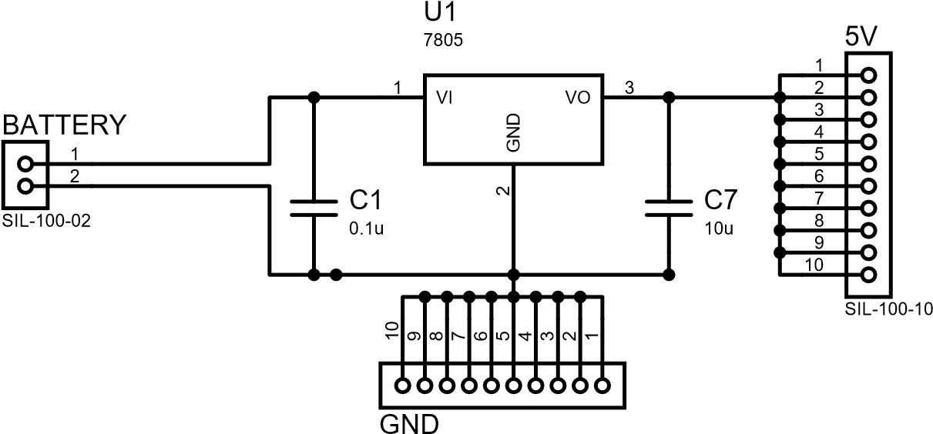

Main circuit

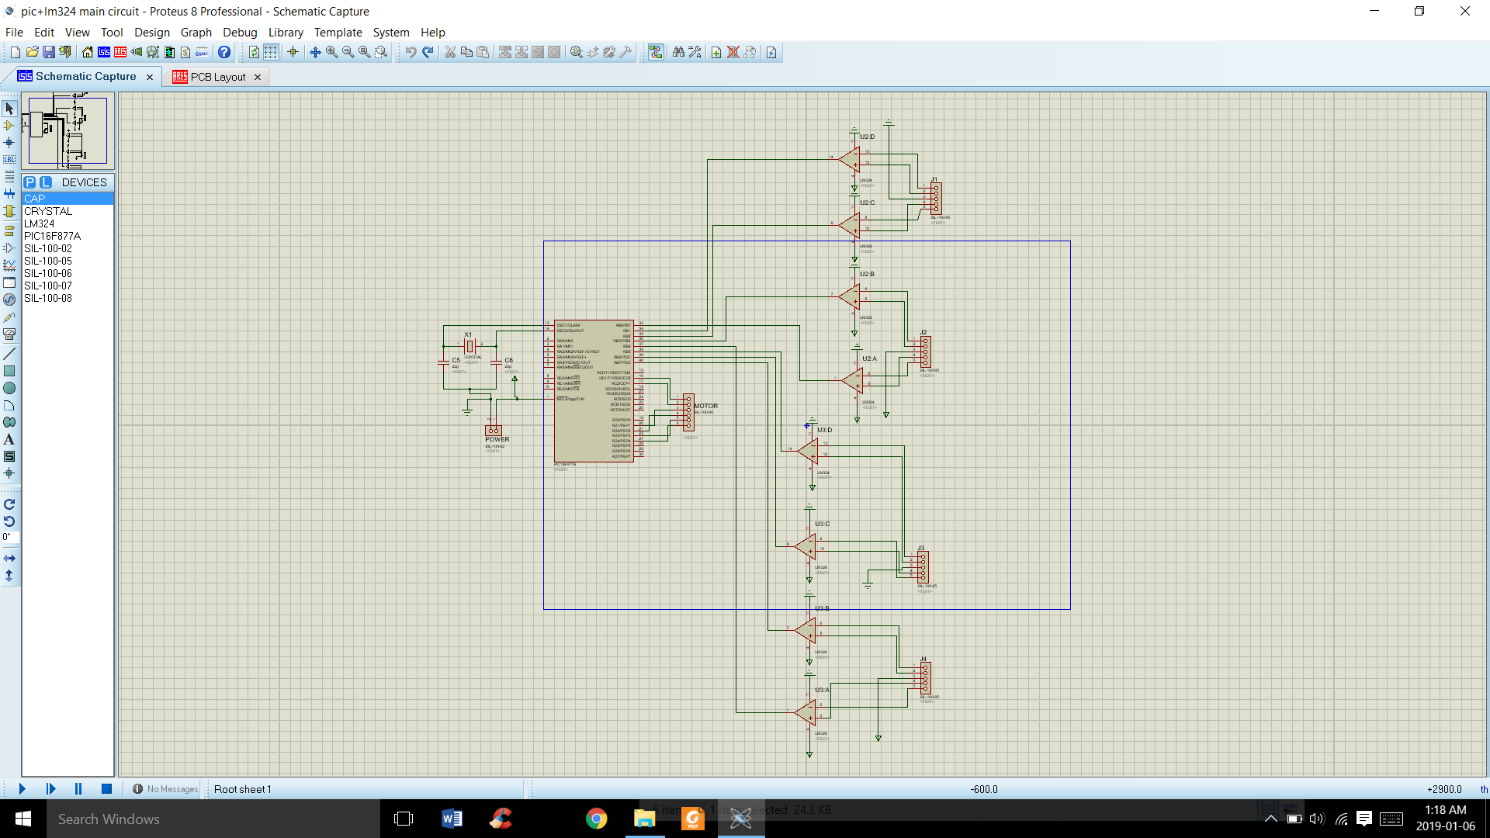

Sensor Circuit

